Ideation Phase
Brainstorm & Idea Prioritization

Date | 30 September 2026
Team ID | SWTID-2026-1669
Project Name | AI WEATHER WISE API
Maximum Marks | 4 Marks
Brainstorm & Idea Prioritization for Weather Wise API :
Weather Wise API can provide accurate and real-time weather information such as temperature, humidity, rainfall, wind speed, air pressure, and weather forecasts. During brainstorming, ideas can include location-based forecasts, severe weather alerts, daily and weekly predictions, historical weather data, and personalized recommendations based on weather conditions. These ideas can be prioritized based on usefulness, accuracy, user demand, implementation difficulty, and reliability. The most important features should be developed first, such as real-time weather updates, forecasts, location search, and weather alerts, while advanced features can be added later to make the Weather Wise API more useful and user-friendly.

Step-1: Team Gathering, Collaboration and Select the Problem Statement:

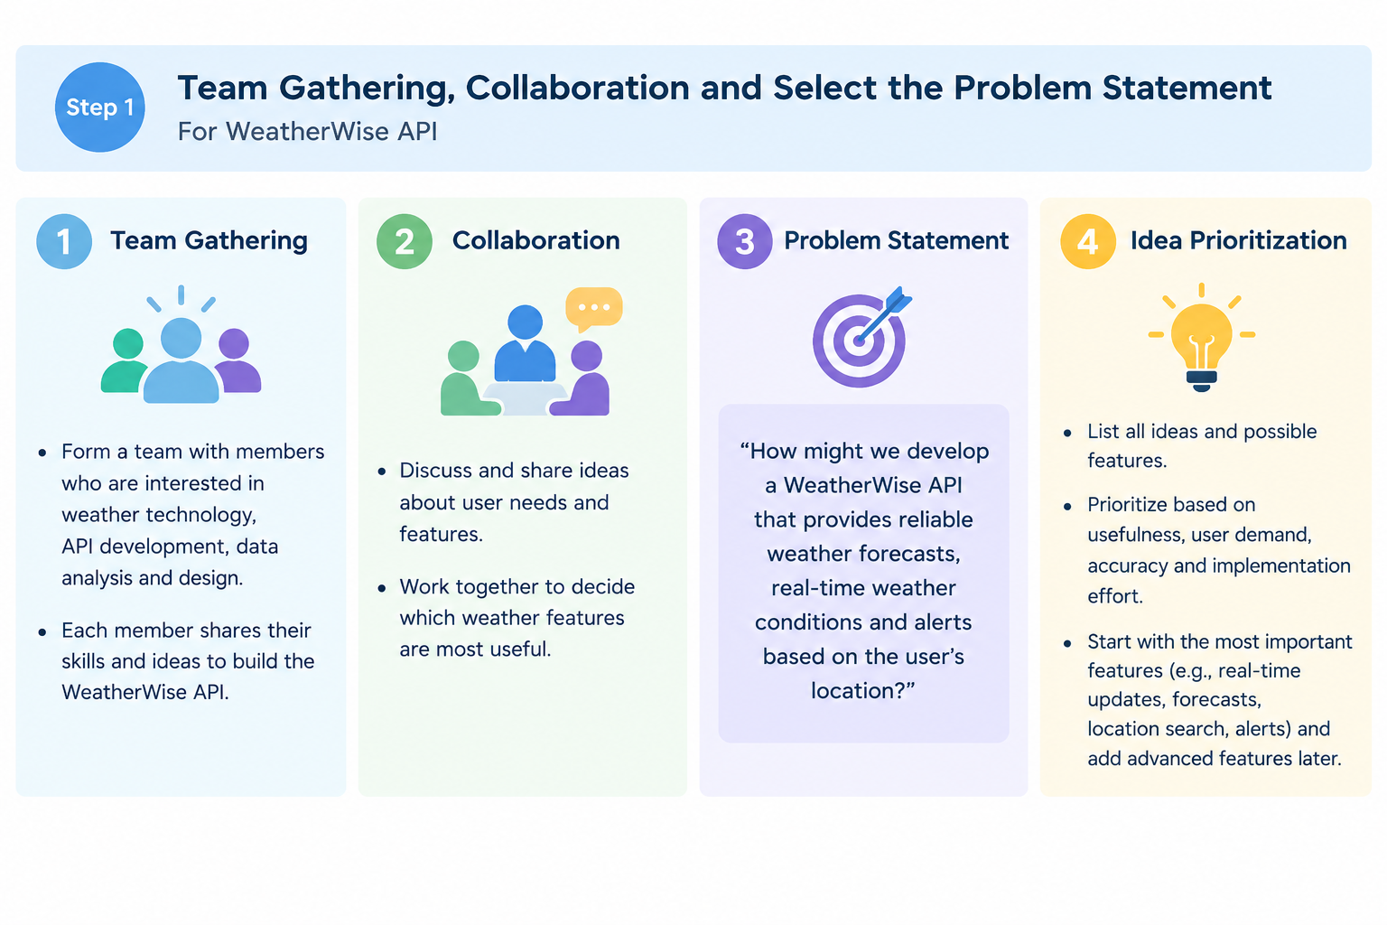

Step-2: Brainstorm, Idea Listing and Grouping

